This document describes the verification guide for the changes done during the **John Hancock - Project Coeus Admin Frontend Assembly Part 1** challenge.

1. Make sure you have deployed the application correctly following the “Deployment Guide.md” at root folder
2. Make sure you have inserted test data using **\TestFiles\TestData.sql**
3. Login with admin, if you have followed user creation from deployment guide, username= CoeusAdminUser and password=password
4. Go to **Edit Fields** menu, the page should as below

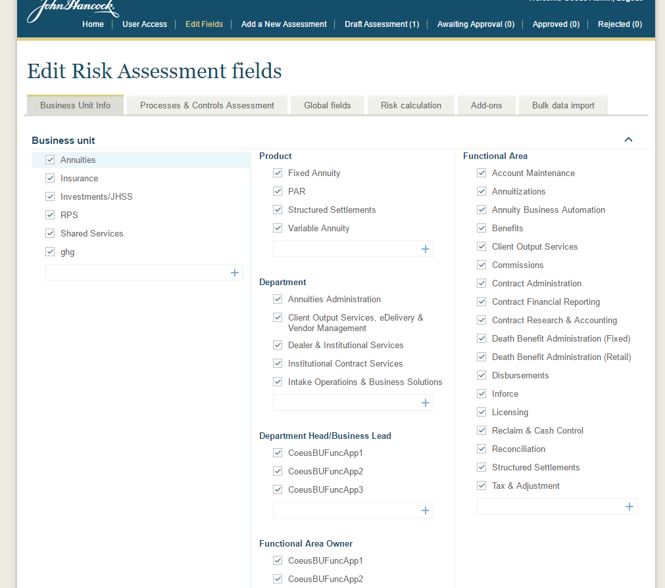

Verify following

* Business unit are selectable. Select different business unit and other items will be populated accordingly
* The checkbox is used to enable/disable the item
* Each item can be sorted within its group by dragging
* Verify new item creation
* Verify update
* Verify delete

**4.1.** Go to “Process And Control Assessment”, you will see as below

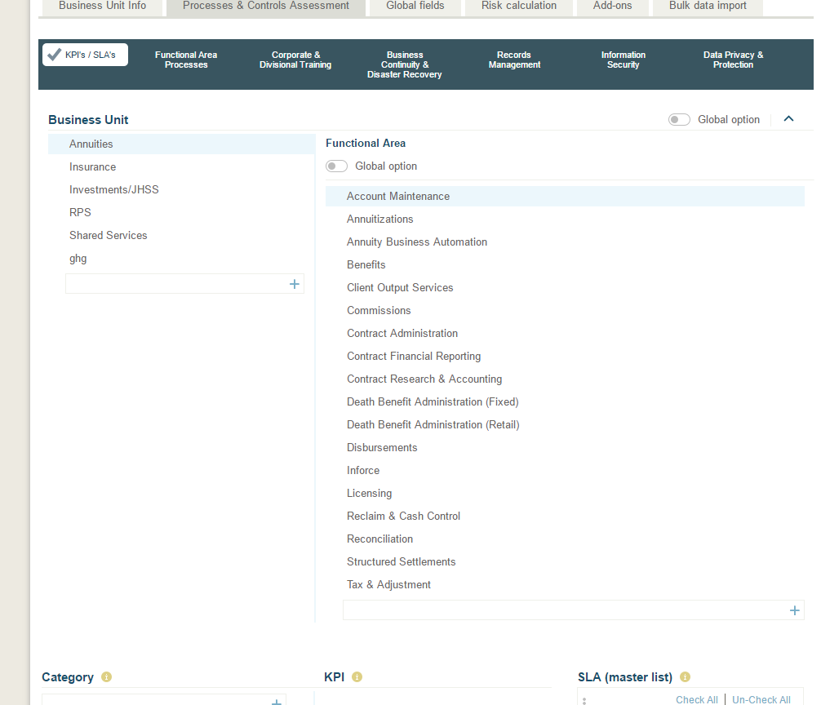

Verify following

* Verify selection of Business Unit (BU) and Functional area (FA) will populate the related category
* Toggle on top “Global Option”, you will see only global KPI Categories i.e. those which are not related to any BU or FA
* Toggle on functional area “Global Option” , you will see only KPI Categories which are global for that business unit i.e. whose functional area is null
* Verify creation of category, KPI
* Verify adding SLA to a category by selecting the desired SLA (using checkbox) and dragging over category item name.
* Verify removing the SLA

NOTE: currently there are only global category available, toggle on top “Global option”

Go to “Functional Area Processes” tab

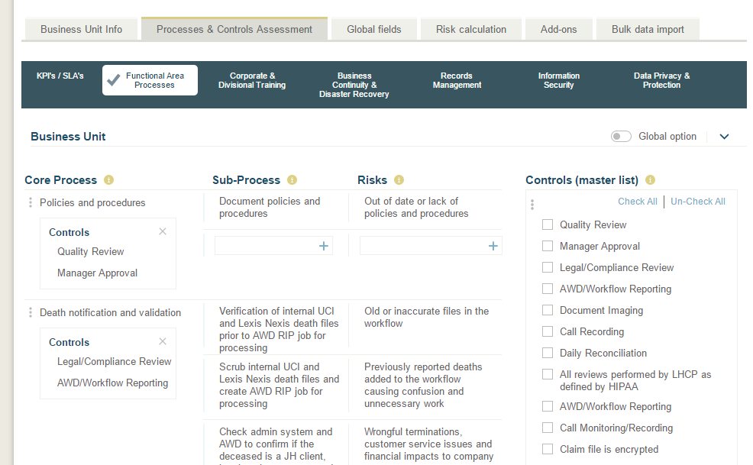

* Verify as previous tab, all feature are same, except we populate the core process instead of KPI Category.

Go to other tab which are very similar to this tab only difference is we load Process Risk instead of core process.

1. Go to Bulk Data Import

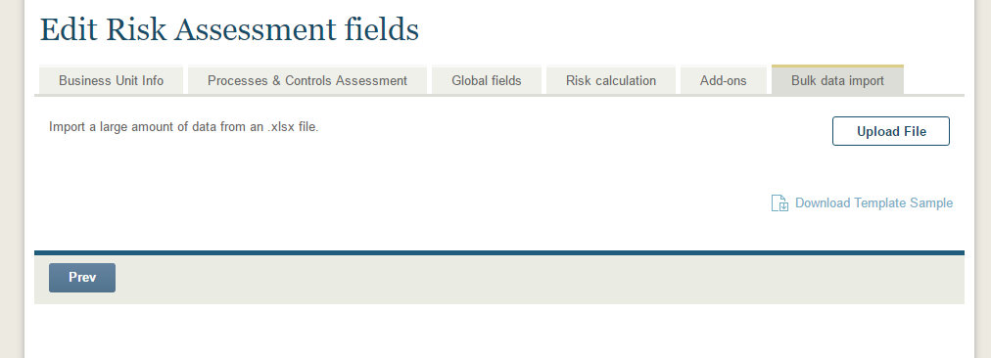

* Verify “Download Template Sample” which will download the excel file template
* Fill the values in excel file and upload it
* To upload click Upload File button a popup should come as
* 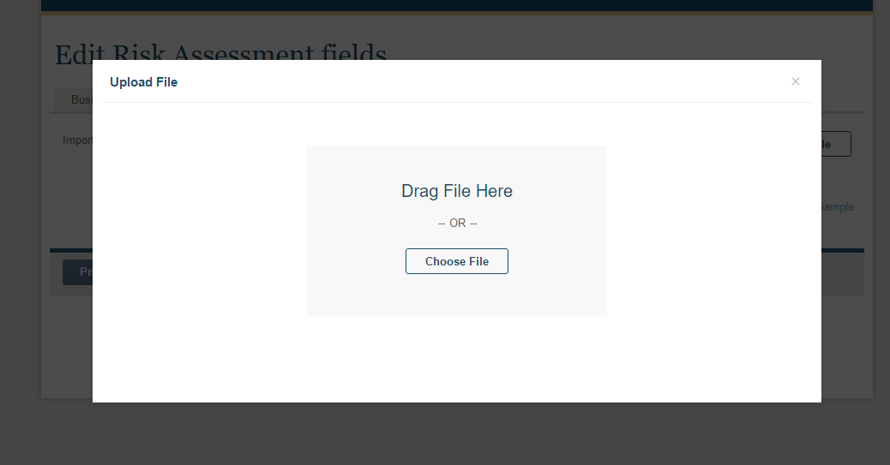
* Select or drop the file and upload will automatically start
* Message will be shown if success or failure